Program 1

WAP to display the given number is even or odd.

#include<stdio.h>

#include<conio.h>

int main()

{

int n;

printf("Enter the number for check num is even or odd : ");

scanf("%d",&n);

if(n%2==0)

{

printf("Number is even",n);

}

else

{

printf("Number is odd",n);

}

getch();

}

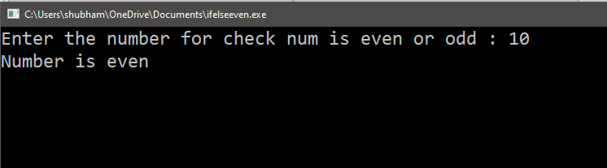

Program 2

WAP to display the given year is leap year or not.

Program 3

WAP to calculate the area and circumferences of a circle.

Program 4

WAP to swap two numbers without using third variable.

#include<stdio.h>

#include<conio.h>

int main()

{

int a,b;

printf("Enter the value a : ");

scanf("%d",&a);

printf("Enter the value b : ");

scanf("%d",&b);

a=a+b;

b=a-b;

a=a-b;

printf("Show the swaped value :\n");

printf("a=%d\nb=%d",a,b);

getch();

}

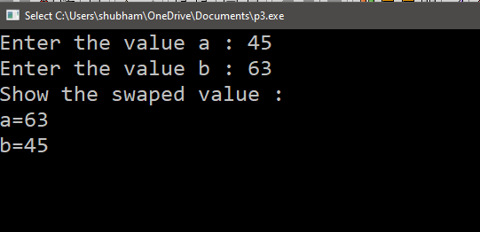

Pragram 5

WAP to calculate factorial of a number using function .

Program 6

WAP to calculate Fibonacci series .

Program 7

WAP to display reverse of a number .

Program 8

WAP to find the sum of digits of a number.

Program 9

WAP to display any given number is palindrome or not.

Program 10

WAP to display the number is prime or not.

Program 11

WAP to search a given number exist in array or not.

Program 12

WAP to find largest and smallest number of an array.

Program 13

WAP to sort the number of the array.

#include<stdio.h>

#include<conio.h>

int main()

{

int a[10],i,j,temp;

printf("Enter the element : ");

for(i=0;i<10;i++)

{

scanf("%d",&a[i]);

}

for(i=0;i<10;i++)

{

for(j=0;j<10-i;j++)

{

if(a[j]>a[j+1])

{

temp=a[j];

a[j]=a[j+1];

a[j+1]=temp;

}

}

}

printf("\nsorted element :\n");

for(i=0;i<10;i++)

{

printf("%2d",a[i]);

}

getch();

}

Output

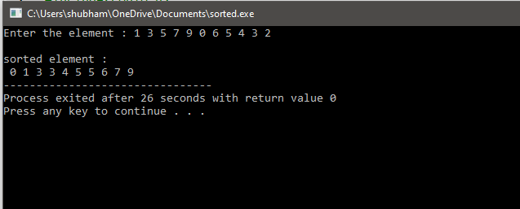

Program 14

WAP to find second largest number of an array.

Program 15

WAP to print transpose of a matrix.

#include<stdio.h>

#include<conio.h>

int main()

{

int a[3][3],i,j;

printf("Enter The Element :");

for(i=0;i<3;i++)

{

for(j=0;j<3;j++)

{

scanf("%d",&a[i][j]);

}

}

printf("\nShow Given Matrix :\n");

for(i=0;i<3;i++)

{

for(j=0;j<3;j++)

{

printf("%2d",a[i][j]);

}

printf("\n");

}

printf("\nShow Of Transpose Matrix :\n");

for(i=0;i<3;i++)

{

for(j=0;j<3;j++)

{

printf("%2d",a[j][i]);

}

printf("\n");

}

getch();

}

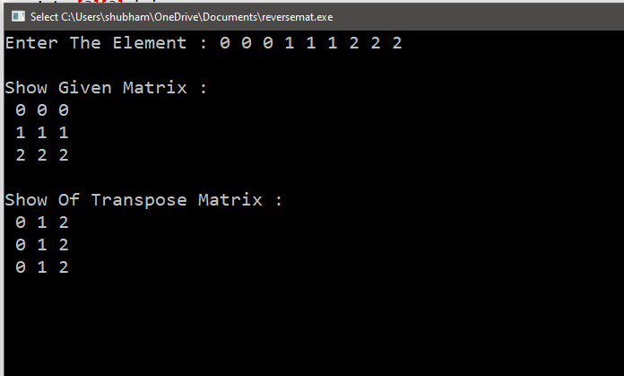

Program 16

WAP to sum of two n\*n matrices.

Program 17

WAP to print product of two n\*n matrices

#include<stdio.h>

#include<conio.h>

int main()

{

int a[3][3],b[3][3],c[3][3],i,j,k;

printf("Enter the num for matrix A : ");

for(i=0;i<3;i++)

{

for(j=0;j<3;j++)

{

scanf("%d",&a[i][j]);

}

}

printf("\nEnter the num for matrix B : ");

for(i=0;i<3;i++)

{

for(j=0;j<3;j++)

{

scanf("%d",&b[i][j]);

}

}

for(i=0;i<3;i++)

{

for(j=0;j<3;j++)

{

c[i][j]=0;

for(k=0;k<3;k++)

{

c[i][j]=c[i][j]+a[i][k]\*b[k][j];

}

}

}

printf("\nShow the matrix A :\n");

for(i=0;i<3;i++)

{

for(j=0;j<3;j++)

{

printf("%3d",a[i][j]);

}

printf("\n");

}

printf("\nShow the matrix B :\n");

for(i=0;i<3;i++)

{

for(j=0;j<3;j++)

{

printf("%3d",b[i][j]);

}

printf("\n");

}

printf("\nShow the matrix Multiplication C :\n");

for(i=0;i<3;i++)

{

for(j=0;j<3;j++)

{

printf("%3d",c[i][j]);

}

printf("\n");

}

getch();

}

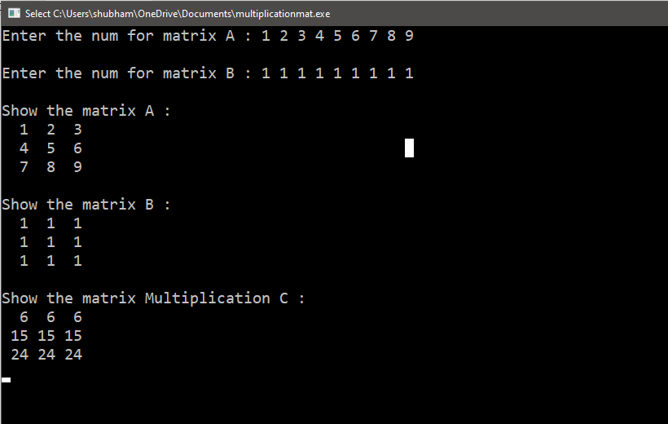

Program 18

WAP to find sum of left & right diagonal in the matrices .

Program 19

WAP to display the pattern –

\*

\*\*

\*\*\*

\*\*\*\*

\*\*\*\*\*

Program 19

WAP to display the pattern –

55555

4444

333

22

1

Program 19

WAP to display the pattern –

a

a a

a a a

a a a a

a a a a a